**RESULTS**

Overall *A. pulchra* was robust to both temperature and injury treatments. We found that injury type and temperature had no effect on coral skeletal accretion; however, regeneration occurs faster in corals injured by fragmentation compared to abrasion, with most corals achieving full regeneration by the end of the experiment. Physiologically we found that temperature elevated coral metabolism, specifically gross photosynthesis and daily P:R.

*Experimental aquaria maintained elevated and ambient seawater temperatures.*

Experimental aquaria were effective in maintaining seawater temperature regimes with an overall mean elevated temperature of 29.51土 0.0045°C and mean ambient temperature of 27.86土 0.0136°C. Across 19 days of the experiment daily mean temperature ranged from 28.74 to 29.70°C and 27.12 to 28.31°C in elevated and ambient aquaria, respectively (Figure S1). Daily differences in temperature between treatments was greater than 1.5°C for 14 out of 19 days of the experiment and greater than 0.85°C for the remaining 5 days.

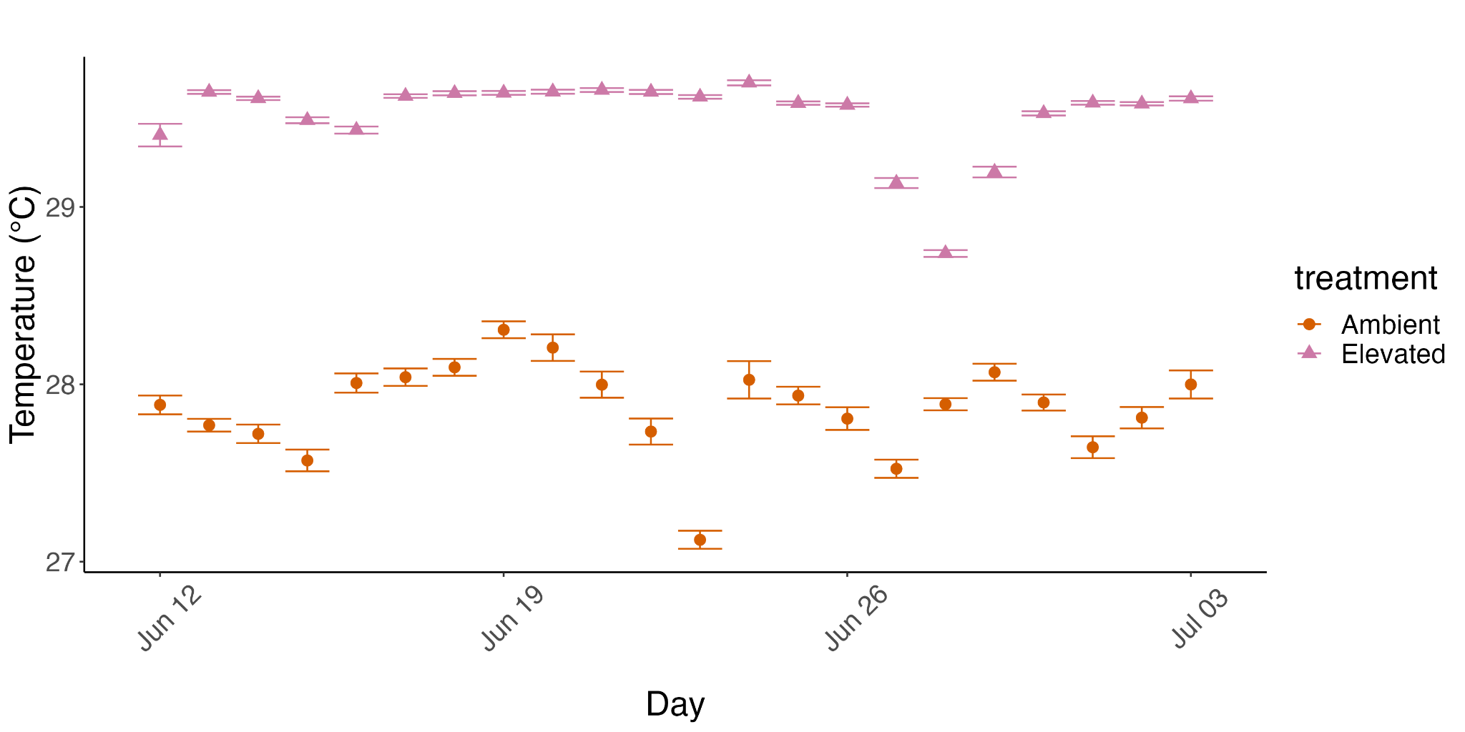Figure S1. Temperature profiles of experimental aquaria. Circles are daily mean temperatures for ambient (orange circles) and elevated (pink triangles) treatments with standard error bars.

*Temperature and wounding had no effect on coral growth.*

Growth rates of *A. pulchra* fragments (N = 71) ranged from 0.59 to 2.59 mg cm-2 day-1 with an average growth rate of 1.62 ± 0.05 mg cm-2 day-1. We did not observe significant effects of injury, temperature, or the interaction between injury and temperature on *A. pulchra* growth rates (Figure 1; Table S1).

*Fragmentation injuries regenerate faster than abrasions.*

By the end of the experiment, 92% (13/14) of *A. pulchra* fragments displayed full regeneration regardless of injury or temperature. However, survival analysis revealed that time to full regeneration was faster in *A. pulchra* injured by fragmentation opposed to abrasion (Table 1). Median time to full regeneration of fragmentation injuries was 10 days, compared to 19 days for abrasion injuries. This finding is supported by Cox’s proportional hazards analysis which indicates that fragmentation has a significant effect on regeneration and that the potential for full regeneration is 1.83 times greater in fragmentation injuries compared to abrasion (HR = 1.83, 95% CI: 1.01, 3.34 P = 0.047; Table 2).

*Elevated temperature increased gross photosynthesis*

We detected a significant interaction between temperature and time on respiration (LMM; F = 10.23, P < 0.01) and net photosynthesis (LMM; F = 21.28, P < 0.001), meaning the effect of temperature on these rates were temporally dependent. Where respiration rates are higher at day 1 compared to day 19 of the experiment, respiration rate decreased significantly through time, Overall, respiration rates ranged from 0.23 to 0.74 umol cm-2 hr-1 ,